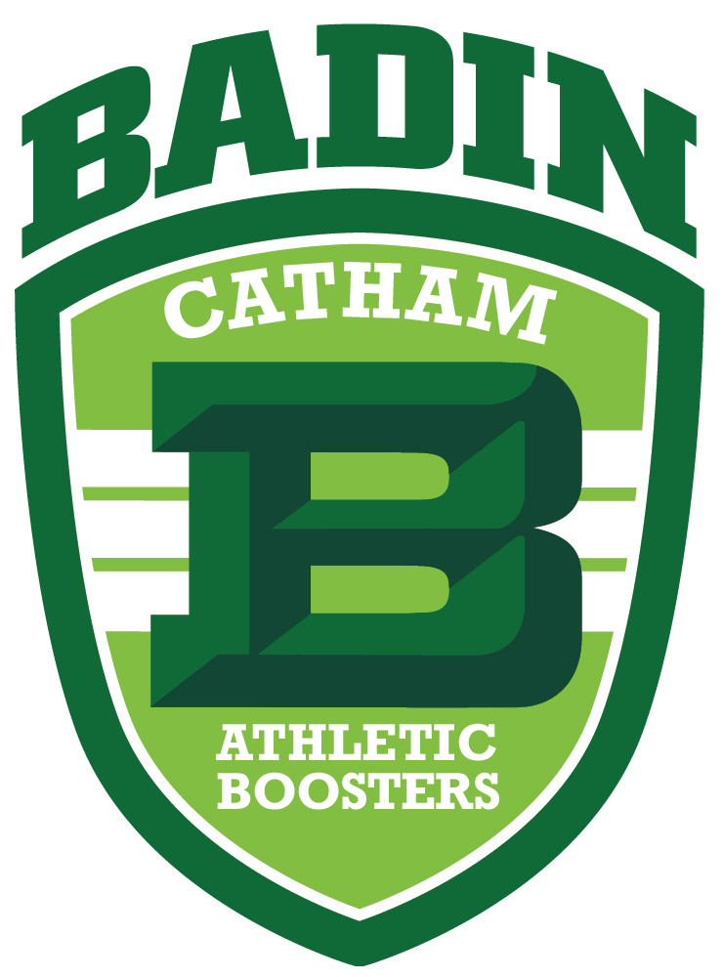July 18, 2025

Dear Badin parents and student athletes,

Catham Club will produce TWO sports program this school year – fall and winter, and your help is needed to sell ads. This is a great fundraiser for the Catham Club, as well as an awesome opportunity to offset the cost of your athletic participation fee.

You can sell ads using the attached ad sales form OR using this online form: <https://payit.nelnet.net/form/8TjVPDuK>. Please share this online link with anyone interested in purchasing an ad!

# Rules & benefits for selling NEW ads:

1. If you sell **(2) ¼ page ads or a ½ page ad**, you will receive $100.00 credit towards the athletic participation fees for one sport/student.
2. If you sell **a full page worth of ads (combination of ¼, ½ and full page ads),** you will receive credit for one entire athletic participation fee for one sport/student. If there are multiple sports or students, you need to sell one full page for each sport.
3. **Parent ads do not count to offset player fees.**
4. Once you sell an ad, it becomes your ad every year it is renewed or until you leave Badin.
5. You may not contact current advertising businesses from the 2024-2025 programs if they were sold by someone else.

# Program ad costs:

* + - * Back Outside Cover (1 available) - $600
      * Front and Back Inside Cover (1 available each) - $550
      * Full Page - $300.00
      * ½ Page - $225.00
      * ¼ Page - $150.00
      * Parent Ad (business card size) - $50/season

If you would like more information on selling ads please contact Sharon Adams [sadams@badinhs.org](mailto:sadams@badinhs.org) or 513-863-3993 x113.

**2025-2026 Athletic Costs/Player**

1st sport - $250

2nd sport - $200

3rd sport - $50

**Ads are due by August 12th, 2025.**

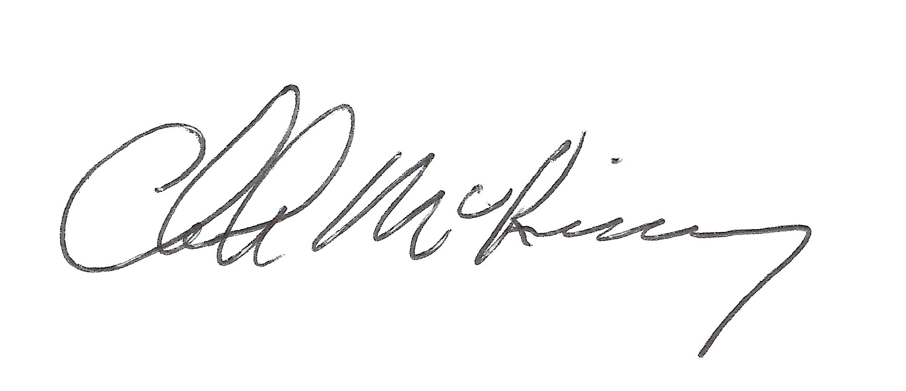Thank you,

Chuck McKinney

Coordinator of Sponsorships